It would be almost impossible to show most electrical or fluid systems in a full-scale detailed drawing. The drawing would be too difficult to make and too large to handle. Instead, symbols are used to represent the parts of a system. The symbols can be combined to show a complete system and how the parts connect with each other. Such a diagram is called a schematic diagram. The symbols and connecting lines on a schematic diagram are standard. Even complex systems are easy to understand if you know how to read the symbols.

This course is a step-by-step approach to the understanding of schematic drawings and flow diagrams. It begins in this lesson with a discussion of the meaning and the value of schematic drawings, plus a description of the different types of drawings that maintenance specialists use on the job. Later lessons in the course describe the symbols that represent the parts of various systems, then portions of systems, and finally complete systems.

Objectives

After studying this lesson, you should be able to…

- State the definition of a schematic.
- List some characteristics of schematics.
- Identify a schematic among other kinds of technical drawings and diagrams.
- Explain how flow is indicated on a schematic.

Key Terms

Symbol

Schematic

Fluid

Direct current

Alternating current

Symbols in Schematics

In several ways, the symbols used in schematics are like the letters of a non-English alphabet or the signs used in .

- Consider the symbol ∆ for example. It is the Greek letter and in math it represents a change or difference. The delta is used to designate common electrical connections, as well as other component parts of a circuit, as shown below:
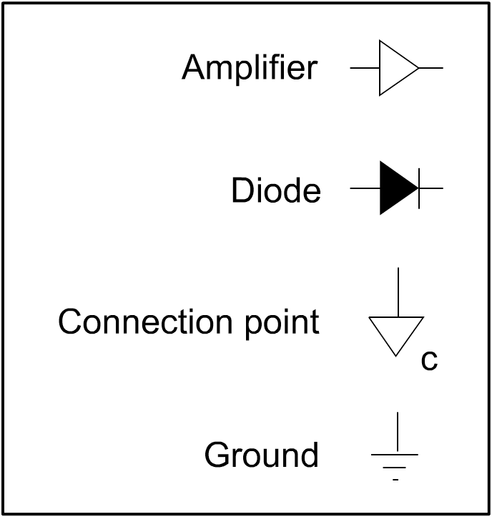

- The symbols are in a meaningful way. Greek symbols are combined to form words and then sentences. Schematic symbols are connected by lines to represent a system.
- Understanding either a foreign language or a schematic requires special training. Maintenance specialists are expected to read and understand schematics. Learning to do so is part of their training. The task may look difficult at first. But it is not— if you learn it one step at a time.

The word schematic comes from the word schema. In Greek, this word means “to form.” In Latin, it means “a figure.” The word scheme has the same origin. A scheme is some kind of plan that has been formed.

A workable modern definition of the word schematic is a drawing made for a or purpose. It conveys a special kind of information. It does so by the use of . These symbols are connected so that the schematic shows what is happening in the electric circuit. To a person who has learned to read schematics, the diagram presents a clear picture of the flow of electricity through the circuit.

Therefore, a better definition of a schematic has five parts:

- A schematic is a line drawing.
- It is made for a scientific or technical purpose.
- It shows how a system works.
- Symbols are used instead of pictures.
- The symbols are connected to show how the system operates.

Using Schematics

This definition of schematics makes it clear why they are used:

- They reduce a complicated system to a manageable drawing that can be understood. Without a schematic diagram, it would be unlikely that anyone could figure out where to look for the cause of any trouble in a complex system. Getting a system into a readable form is an important reason for using a schematic.
- They show what is happening. The relationships among the various elements are shown by lines. A skilled reader of schematics can see how the system is intended to work.
- They standardize the drawings of systems. A schematic can be read by anyone who understands electrical schematics. The and
are standard. You need very little written information in addition to the schematic to complete the description of how the system works.

Schematics are important to maintenance specialists. When a breakdown occurs in a system, they read the schematic and figure out what might have gone wrong. From the diagram, they can tell where the is and how to turn it off. They can tell how the different components are connected in the system, so they can make intelligent guesses about how one component affects the others. Finally, when they discover the problem, they see how to make the corrections necessary to get the system back in working order.

The question of how schematics are used has multiple answers:

- To the parts of the system.
- To show how the system .
- To help maintenance personnel a system that has failed.

You will use schematic diagrams in many ways. They are important sources of information. This course describes three major kinds of schematics—electrical, fluid power, and piping. When you understand schematic diagrams in these areas, you will have little difficulty understanding other uses of schematics.

Electrical Schematics

Electrical schematics can show all kinds of circuits, from the very simple to the very complex. If you look at a diagram of a circuit in your plant, you might already know how to read some or all of it. Symbols often look like the devices in the circuit. A complete pictorial representation of every device in a complex electrical system would be expensive and time consuming. The result would be very large. Moreover, a change in the shape of one device would make the whole diagram out of date.

In your maintenance work, you may come across diagrams that include pictures or simple outline drawings of component parts. As long as the drawing meets all the other parts of the definition, you can consider it a schematic.

Pneumatic and Hydraulic Schematics

The second major area in which schematics are used involves the flow of fluids in machinery. A fluid is any substance that can . All liquids and gases are fluids. A system that works by flowing gas is called a system, based on the Greek word pneuma, meaning “air.” A system that works by a flowing liquid is called a system, based on the Greek hydro, referring to water.

Four kinds of pneumatic and hydraulic diagrams are commonly used in plants:

- The diagram is a double-line drawing showing a system in some detail.
- The diagram is a single-line drawing in which simple outline drawings represent the components of the system. In this diagram, the components are also listed.
- The diagram is a single-line diagram that fits the definition of a true schematic. It uses symbols. The schematic is the most important kind of diagram to the maintenance specialist.

- A diagram includes elements of the first three kinds. Combinations are often encountered on the job.

Piping Schematics

The next major area in which schematics are used is piping. In the typical plant, piping is used in almost every work area. It serves many purposes. Fluids of all kinds flow through pipes during production, distribution, and final use. Whether you are dealing with air in a pressure line or acids in a chemical process, piping plays a key role in your plant.

Maintaining pipes, fittings, and valves is crucial to the continuing success of any piping system. A leak in a hydraulic or pneumatic system can cause the entire system to fail. Even more important, a leak can be . Therefore,
maintenance of a piping system is more important than repairing the system after a breakdown.

Schematic drawings of a piping system provide the information you need to maintain the system. If a breakdown occurs, the drawing shows you where the valves are and where to check to locate the problem.

There are two general kinds of piping diagrams—single line and double line. The
-line drawing is similar to an electrical schematic. It uses symbols for all the components of the drawing. Like the electrical schematic, the single-line drawing fulfills all five parts of the definition of a schematic.

The -line drawing is a pictorial view of the pipe, joints, valves, and other components. It fulfills some of the five parts of the definition of a schematic.

Value of Schematics

Schematic diagrams are valuable for the following reasons:

- They make systems easier to understand.
- They show what is happening in electrical, fluid-power, and piping systems.
- They use symbols.

As a maintenance specialist, you will learn to depend on schematics. They will help you understand what is happening in a system. You would find it very difficult to understand even a simple system without the proper schematic.

Looking for Flow

When a system fails, there is a breakdown in . That is, the movement of electricity or fluid through the system is interrupted. In an electrical system, an interruption may result from a circuit that opens a circuit breaker, or from a broken . In both cases, the result is a halt in the flow of electricity, usually producing obvious signs. In a piping system, the flow may continue. If it does, a leak appears at the point of breakdown.

Any breakdown—any interruption of flow in a system—results in a call to the maintenance department. If you are sent out on the job, you might find the problem so obvious that you can fix it on the spot, without using any diagrams at all. But for more complicated problems, you will probably need to use a schematic of the system. The first thing you will want to know is how electricity or fluid should flow through that system.

In order to understand how electricity or fluid flows through a system, you must know how to look for the indications of flow on an electrical or a piping schematic.

Electric Current

The flow of electricity is similar to the flow of fluids. All fluids flow from
pressure to pressure. Electricity flows from
voltage to voltage. But you must be careful to avoid confusion between positive and negative values in electricity.

Electric is the flow of within a conductor. An electron is one of the most basic particles of matter. It is smaller than an atom, and its mass is only a fraction of the mass of the smallest atom. Every electron carries a
electric charge. That is, the charge matches the charge found on the negative terminal of a battery.

Electrons flow from to . Because like charges repel each other, the negative charge of a battery terminal repels the negative charge of the electron. The positive charge on the other terminal of the battery attracts the negative charge of the electron. An electron is at higher charge, or potential, at the negative terminal than at the positive terminal.

You must be careful to avoid confusion between positive and negative. Some people refer to a flow of imaginary positive particles, moving from positive to negative. Others refer to current as electron flow—from negative to positive. In order to avoid confusion, this lesson and the remainder of this course will stick to just one idea of current. The term current will always mean the flow of electrons—from negative to positive.

Direct current. Even though you stick to this one idea of electron flow from negative to positive, you must distinguish between two ways in which current can be made to flow. Electric current that flows steadily in one direction is called current, abbreviated .

To understand the flow of electrons in a dc circuit, you must first locate the
of voltage on the schematic. Then you can follow the paths of the electrons through the wires and devices to the other terminal of the voltage source or to the ground.

Alternating current. Many electric circuits use current that constantly changes direction. The current flows in one direction, then reverses, and then changes back to the first direction. It normally goes through this cycle times per second. A current that alternates from one direction to another continuously is called
current, abbreviated .

You can think of alternating current in much the same way as direct current. Even though the current keeps reversing, the power of an ac circuit behaves in the same way as the power in a dc circuit.

There are no positive or negative signs on the schematic for an ac (alternating current) circuit. To trace current flow, you must look for other labels or for colors. Common labels are L1 and L2 (for Line 1 and Line 2). Common colors are black, red, and white.

Fluid Flow

The primary way to indicate flow in piping diagrams is with . Alternate flow is sometimes shown in a separate, smaller diagram. For example, a main diagram may show the flow when the control valve is “up.” But the valve also has a “down” position, which reverses the direction of flow in some pipes. This reversal may be shown in a supplementary diagram next to the main diagram.

Sometimes the arrows will not be very obvious. In piping schematics, the flow is usually shown by drawn directly on the .

What do you do when there are no arrows at all in a diagram of a piping system? It sometimes happens. Then you have to use your own judgment, based on what you have learned from your training and experience. In some cases, you may need to test the system to determine the direction of flow. But in most systems, you can figure out the direction if you look for clues.

Certain clues usually appear in a schematic. You may be able to see the starting point of a flow by noticing the location of symbols for , , and other equipment. The final destination of a fluid may be found by looking for control valves, return lines, or . The basic design of the system may give you important clues about the direction of flow.

Once you have determined the direction of flow at one point or at a few points, you can probably trace the fluid through the system even if the diagram shows no arrows.
Sometimes the of the piping can help you make good judgments. But watch out and always think things through. For example, a Y-fitting may use one arm of the Y to bring extra fluid into the system, or to take fluid out of the system.

Summary

A schematic has five distinct features:
  - It is a line drawing.
  - It is made for technical purposes.
  - It shows how a system works.
  - It uses symbols rather than pictures.
  - The symbols are connected by lines.

Even when pictures are used, the diagrams serve the same purpose as schematics and you can read them as such.

Schematic drawings have many functions. Electrical schematics show how electricity flows. Pneumatic and hydraulic schematics show the flow of fluids in machinery. Piping schematics show the flow of liquids and gases.

If you know how to read schematics, you will be able to understand how the apparatus is intended to work. This knowledge will help you figure out how to repair a system if it breaks down. Even more important, you will be able to check it to prevent a breakdown. Prevention of problems is the best kind of maintenance. It almost always involves reading a schematic.

