Reading Schematics and Symbols Electrical Symbols—Unit 102, Lesson 3

Preface

Every type of engineering has its own set of symbols for use in drawing diagrams of equipment. As a maintenance specialist, you must know these symbols so that you can read the diagrams and keep the equipment in working order. You are the vital link between the engineers who design and build equipment and the workers who operate the equipment. To do a good job, you must be able to “speak” both languages.

Some electrical symbols look like the components they represent. Some look like key parts of the components they represent. Other symbols do not look anything like the components they represent. It is easy to learn to read symbols in the first group. It is harder to learn to read those in the second and third groups. Practice will be your best teacher. The more you use schematics and the more you read the important symbols on them, the easier it will be to remember what those symbols mean.

This lesson introduces some of the basic electrical symbols. But there are many more symbols than it is possible to include here. You will learn the important symbols as you get more experience on the job. This lesson is intended to get you started on your way with some examples of the most important group of symbols.

Objectives

After studying this lesson, you should be able to…

- State the meaning of symbols and lines on an electrical schematic.
- Explain the difference between a fuse and a circuit breaker.
- Explain how to trace an electrical circuit.

Key Terms

Battery

Cell

Winding

Overload

Potentiometer

Rheostat

Wires and Connections

An electrical schematic is made up of symbols and lines. The symbols stand for fuses, motors, heating elements, and other components in the circuit. The lines stand for
connecting these components. Different kinds of lines have different meanings in schematic diagrams. A usually indicates their meaning.

In order to understand electrical schematics, you must observe how the lines on the diagrams . Intersecting lines can show that two or more wires are connected, or they can show that the wires pass over or under each other without connecting. A at the intersection indicates an electrical connection. The dot is necessary only when the meaning would be unclear without it. If it is clear that the wires connect, the dot is not needed.

Being able to tell the difference between wires that connect and those that do not is one of the most important parts of reading an electrical schematic. Knowing this difference will help you trace the current in a circuit.

Switches

Wires carry current from one place to another in an electrical system. A is a device for making or breaking the electrical connection at one point. By making or breaking connections, you can start, stop, or change the direction of flowing in a circuit.

A large switch, called a , is used for cutting off the power from a plant or part of a plant. You will usually see this kind of switch where the electric service enters the plant or a department. The number of used and their size depend on how much electric power must flow through the switch.

A pushbutton switch typically operates a single electric circuit. Pushing a button may either or the contacts in the switch. Some switches are designed so that the contacts stay in the new position until you push a second button. In other switches, the contacts return to their previous position as soon as you release the button. Usually, you can tell how the switch operates from the symbol for the switch.

Power Supply

Most plants receive power from the transmission lines of a company. The entry of power lines into the plant’s electrical system can be shown in several ways on a schematic.

Another source of power is a , which consists of two or more cells. Each cell is a unit that produces electricity by means. The cells can be connected together to produce the necessary and . For

example, a 12 V (volt) storage battery might consist of six 2 V cells. A 1.5 V flashlight “battery” is actually a single cell. Two or more of these cells in a flashlight make up a true battery, but a small one. The battery that runs a lift truck, on the other hand, has many cells. It is large and heavy.

In the symbols for a single cell and five-cell batteries, the long line represents the terminal of each cell, and the short line represents the
terminal. This is an important distinction, because the + and
– signs are usually omitted when cell or battery symbols appear in a schematic.

Electric power entering the plant in a transmission line is at voltage. The voltage may be many thousand volts, for example. Voltages as high as this are sometimes necessary to make up for the energy that is lost in the of electric current from the power plant to the users. The loss of energy can be quite large in long transmission lines.

Electricity entering the plant must be “stepped down” in voltage. reduce the voltage for safety reasons and to match the electrical needs of various shops and departments. Most industrial motors, heaters, and other electrical equipment operate on 120, 240, or 480 V.

High-voltage transmission lines come in pairs and in groups of three. The lines connect to an outside transformer. Wires called carry electricity from the outside transformer to other transformers throughout the plant. Finally, lines carry current from the last transformer to a circuit breaker panel. These lines supply electricity for the power and lighting circuits. Plant machinery, lights, and office equipment are connected to these circuits.

Electrical Loads

The purpose of an electric circuit is to provide a complete path for electric current. Each circuit may operate one device or several. Common devices include motors, heaters, and electric lights. Each device that uses electricity is called an electrical . Each load uses electric .

You should become familiar with the symbols for common loads and other components in electric circuits. But you should expect to find symbols on the job that you will need to look up in the legend or in a table of electrical symbols.

Every complete circuit has at least one load, plus wires connecting the terminals of the load to the power source. This source can be a battery, a generator, a transformer, or a power panel. The circuit probably also includes a to control the load.

Coils and Transformers

You may already have worked with coils (also called ). The ballast in a fluorescent lamp is an example of a coil. Electromagnets, solenoids, and alarm bells use coils as . A coil (or inductor) consists of a coil of , usually wound around a magnetic .

When electric current flows through a coil, it creates a . The magnetism causes certain effects needed in electric circuits. You do not need to understand these effects in order to read schematic diagrams. But you do need to recognize the symbols for coils and inductors.

Machines must have the correct voltage in order to run properly. But several machines in a circuit may require different voltages. Or the same machine may require two or three different voltages at the same time. For example, the controls on a large machine generally require lower voltage than the motor.

To handle differences in voltage, are included in many electric circuits. A transformer is a device that changes electricity from one voltage to another. The transformer consists of two coils, called .

The transformer windings are placed side by side or one inside the other in the transformer. One winding is connected to the source of power. It is called the
winding. The other winding is connected to the load. This winding is called the winding.

As current flows through the primary winding, it creates a current flow in the secondary winding. The voltage produced in the secondary winding may be either higher or lower than the voltage delivered to the primary winding. The ratio of voltages equals the ratio of of wire in the primary and secondary windings.

Shown below are some of the basic symbols that are used to designate transformers on schematic diagrams. The symbol at upper right gives the transformer number (52), plus its rating: 600 A at 1500 MVA. A volt-ampere is a , so 1500 MVA is really 1500 MW (megawatts)—a heavy-duty transformer.

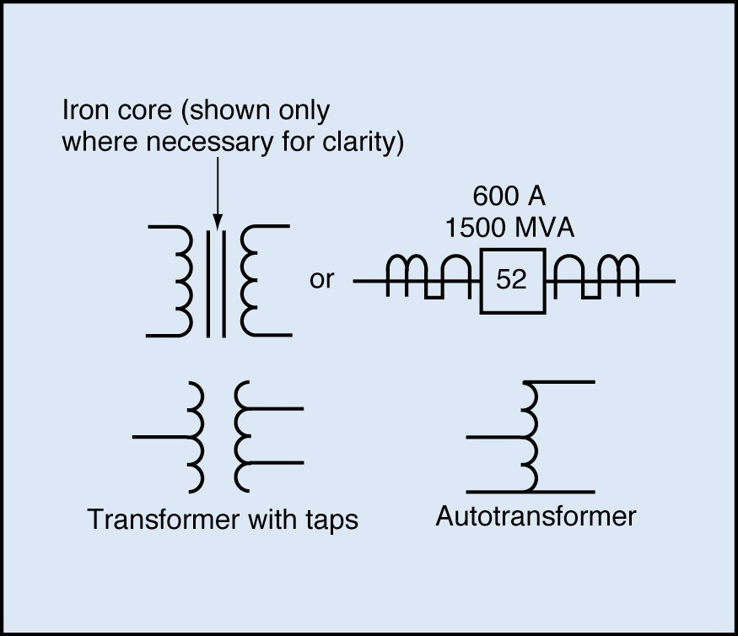

Fuses and Circuit Breakers

Most electric circuits include safety devices to protect against electrical overloads. An electrical overload is an excessive flow of electric current. If too much current flows in a circuit, it can the wiring, damage the components of the circuit, or even cause a fire.

A is a device that automatically opens a circuit when the current rises above a certain limit. When the current becomes too high, part of the fuse melts. Melting leaves a gap in the electrical path, stopping the of electricity. The fuse must be replaced in order to restore electric service.

Typical low-current fuses are the fuse. Knife fuses are typical for higher currents. All types of fuses are shown by the same symbols. Shown below are some basic symbols for fuses.
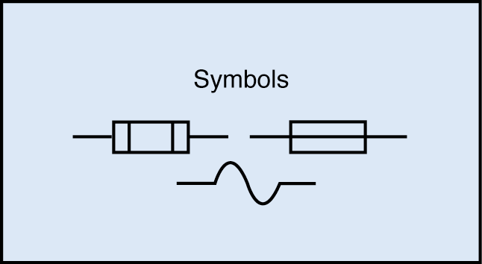

A circuit breaker is similar to a . It automatically opens the circuit if too much current flows. It serves the same function as a fuse, but it can be to restore electric service after the problem has been solved. Shown below are symbols used to represent common circuit breakers.
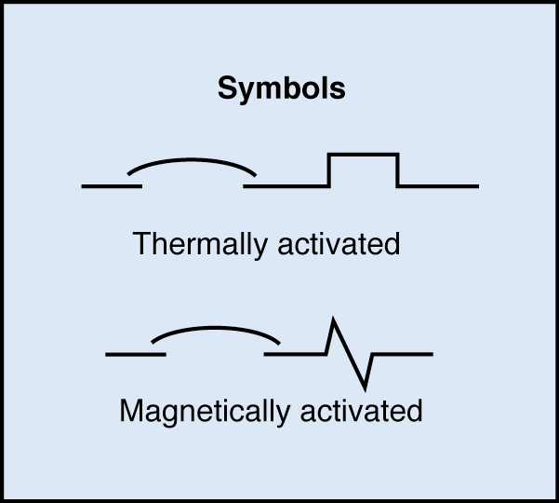

Circuit breakers operate by or action, or by a combination of the two. A thermally activated circuit breaker has a device that gets
as the current increases. If it gets too hot, it opens the contacts in the circuit breaker. A magnetically activated circuit breaker has a within it. The magnetic force of the coil gets stronger as the current increases. If the current gets too great, the magnetic force opens the contacts.

Grounding

Alternating-current systems of 50 V or more are normally grounded. Grounding usually means connecting to the . Everything that is electrically connected to the earth is . That is, it is neither positive nor negative.

Grounding is a means of for people and equipment. Single-phase power systems always have one conductor grounded. This conductor is called the
. As you read in Lesson One, component parts may also be grounded to the metal frame, or chassis, of electrical equipment.

Contacts

Electrical contacts join two conductors in an electric circuit. Usually, the conductors
are wires. Normally contacts allow current to flow when the switching device is at rest. Normally contacts prevent current from flowing when the switching device is at rest. When you activate a switching device, its contacts change to the opposite state. NO contacts snap closed, and NC contacts snap open. A
is a switch with both NO and NC contacts.

Contacts may be designed with special features. Some, for example, have a built-in time delay before they open or close. These features are indicated by next to the symbol.

Resistors

Resistors are used for controlling the current flowing in a circuit. A fixed resistor provides a constant amount of in a circuit. A variable resistor can be adjusted to provide different amounts of . A resistor also acts as a load in a circuit, in that there is always a drop across it. A resistance heating element, for instance, is a form of fixed resistor, and the same symbols are used for both. A variable resistor used for controlling voltage is called a . A variable resistor used for controlling current is called a . In general, potentiometers have high resistance and carry low current. They are used mainly in electronic equipment. Rheostats generally have low resistance and carry high current.
They control motors, magnets, and other equipment that exerts force and performs work.

You do not need to understand how resistors, potentiometers, and rheostats work in order to read their symbols. The symbols for resistors, potentiometers, and rheostats appear below. They are grouped together because they serve similar purposes.
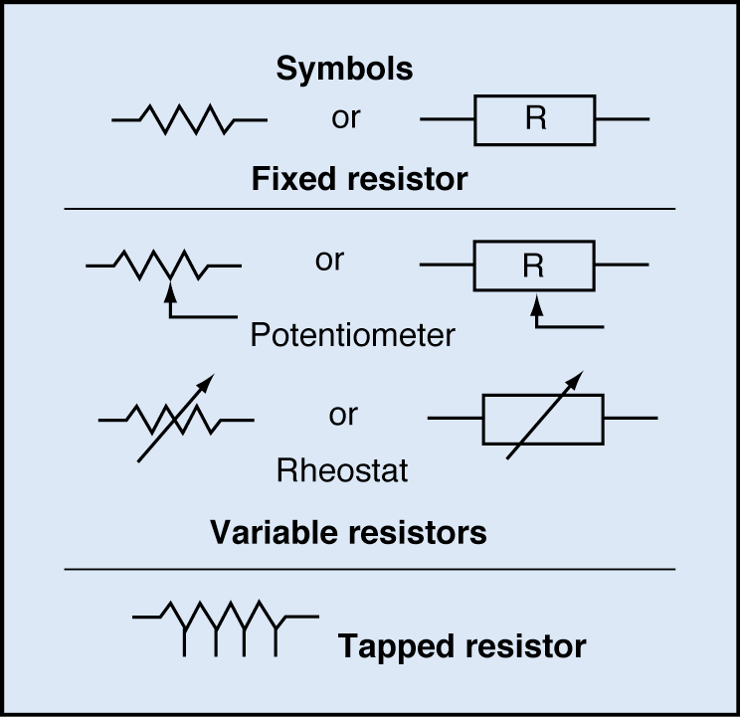

Symbols can sometimes be tricky to interpret. Although some symbols resemble the components they stand for, many symbols look completely different from the elements they represent. In addition, a small difference in the appearance of a symbol may make a large difference in its meaning. Whenever you feel unsure about the meaning of a symbol, you should look it up in a table.

Symbols in a Diagram

You will often use tables of symbols to be sure you understand all of the elements on a diagram. Once you understand the symbols on a schematic, you can trace through the circuit to see the relationships among the components. In doing so, it is important to understand that a schematic indicates .

A logical starting point for tracing any circuit is the . Then start tracing from there. You might want to label each component on a diagram as you find it.

The first element you might see in each line is a circuit breaker. Next might be a transformer. In addition, you could expect to find fuses, switches, and one or more loads. Once again, remember to start at a point, usually the power supply and usually at the top of the diagram.

Summary

This lesson describes some of the most common electrical symbols you will see in your work. Electrical wires and connections appear in every schematic. They show how the components are connected to each other. Electrical switches control the flow of electricity through various parts of a circuit.

Any device that uses electric power is called a load. Examples described in this lesson include motors, coils, and resistors. Coils may be used singly in relays, solenoids, and circuit breakers, or they may be used in pairs in transformers and motors.

Circuits must be protected from electrical overloads that may damage components. A fuse protects a circuit by melting if too much current passes through it. A circuit breaker acts like a switch that opens automatically. After the problem has been solved, the circuit breaker can be reset to restore electric service. A fuse must be replaced.

Electric circuits must be as safe as possible for people who use them. Therefore, various parts of the circuit are connected to the ground. This connection helps to prevent electricity from flowing through a worker’s body to reach the ground.

11 Electrical Symbols—Unit 102, Lesson 3
TPC Training Systems

